3.3HW.R
Garrett Warr
2025-02-12
3.96 (10 pts) Brain Hippocampal Size Exercise 2.165 introduces a study examining the relationship between football playing and hippocampal volume, in μL, in the brain. We use the n = 25 participants in the control group to estimate average brain hippocampus volume for all non-football playing people. Use the dotplots in Figure 3.22 to answer the following questions.
a. Two dotplots are shown: one shows the original data and one shows a bootstrap distribution from the data. Which is which? The original is in Dot plot 1 and the bootstrap is show in Dot plot 2
b. Estimate the sample mean hippocampal volume based on the graphs. Give the correct notation and the value. The value of is x-Bar from the graphs is going to be 7,600
c. Use the graphs to roughly estimate the standard error if we use this sample mean to estimate hippocampal volume. The standard error of this would be 1200 divided by 6 so the standard error will be around 200 SE
d. Does the standard deviation of the original data appear to be larger or smaller than the standard error? Larger
e. Use the estimated mean and the estimated standard error to find and interpret a rough 95% confidence interval for the mean hippocampal volume. 95 percent Cl = x hat + or _ z times SE. So 7600 + or – (1.96 x 200) = 7208 to 7992
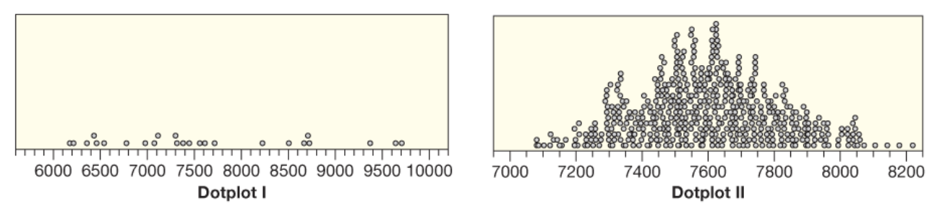

3.101 (12 pts) Automobile Depreciation For a random sample of 20 automobile models, we record the value of the model as a new car and the value after the car has been purchased and driven 10 miles. The difference between these two values is a measure of the depreciation on the car just by driving it off the lot. Depreciation values from our sample of 20 automobile models can be found in the dataset CarDepreciation.
- (2 pts) Find the mean and standard deviation of the Depreciation amounts in CarDepreciation.
- (6 pts) Use R and RStudio to create a bootstrap distribution of the sample mean of depreciations. Describe the shape, center, and spread of this distribution.
- (4 pts) Use the standard error obtained in your bootstrap distribution to find and interpret a 95% confidence interval for the mean amount a new car depreciates by driving it off the lot.

library(Lock5Data)
library(tidyverse)
## ── Attaching core tidyverse packages ──────────────────────── tidyverse 2.0.0 ──
## ✔ dplyr 1.1.4 ✔ readr 2.1.5
## ✔ forcats 1.0.0 ✔ stringr 1.5.1
## ✔ ggplot2 3.5.1 ✔ tibble 3.2.1
## ✔ lubridate 1.9.4 ✔ tidyr 1.3.1
## ✔ purrr 1.0.2
## ── Conflicts ────────────────────────────────────────── tidyverse_conflicts() ──
## ✖ dplyr::filter() masks stats::filter()
## ✖ dplyr::lag() masks stats::lag()
## ℹ Use the conflicted package (<http://conflicted.r-lib.org/>) to force all conflicts to become errors
CarDep <- data("CarDepreciation")
head(CarDepreciation)
## Car New Used Depreciation
## 1 Mazda3 17956 15326 2630
## 2 Buick Encore 23633 21498 2135
## 3 Toyota Corolla 16091 14761 1330
## 4 Chrevolet Tahoe 45489 43463 2026
## 5 Chrevolet Equinox 21596 19149 2447
## 6 Ford Fiesta 14246 12220 2026
# step 1 Find mean and SD
mean_depreciation <- mean(CarDepreciation$Depreciation)
sd_depreciation <- sd(CarDepreciation$Depreciation)
mean_depreciation
## [1] 2355.85
sd_depreciation
## [1] 857.9969
# Step 2 Create a bootstrap
# Load necessary library
library(boot)
boot_mean <- function(data, indices) {
return(mean(data[indices]))
}
set.seed(123)
bootstrap_results <- boot(CarDepreciation$Depreciation, boot_mean, R = 10000)
bootstrap_means <- bootstrap_results$t
hist(bootstrap_means, main="Bootstrap Distribution of Mean Depreciation",
xlab="Mean Depreciation", col="lightblue", breaks=30, border="black")
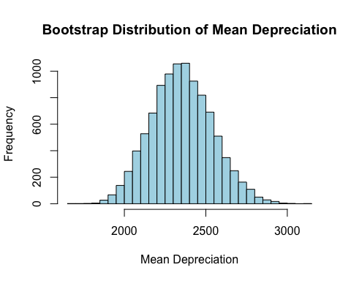
# Describe the Bootstrap Shape = Normal center, Center = Close to mean
se_bootstrap <- sd(bootstrap_means)
se_bootstrap
## [1] 187.3405
# Step 3 95% confidence interval
# Compute the standard error
se_bootstrap <- sd(bootstrap_means)
ci_lower <- quantile(bootstrap_means, 0.025)
ci_upper <- quantile(bootstrap_means, 0.975)
se_bootstrap
## [1] 187.3405
ci_lower
## 2.5%
## 2003.449
ci_upper
## 97.5%
## 2737.801

